***DATABASE PROJECT***

**Project Name: Burger Shop Management System**

**Content List:**

■ Introduction

■ Scenario

■ ER Diagram

■ Normalization

■ Table Creation

■ Data Creation

■ Query Writing

■ Conclusion

**■ Introduction:**

The database is a collection of organized set of data that make it straightforward to access, manage, manipulate and update as well. In short, it makes the management of data easy. A (DBMS) Database Management System is not just one thing, it is a collection of programs that serve different purposes.

In our project (Burger Shop Management System) was created by the concept of DBMS.

■ Scenario:

'Khaidai Burgers Shop' is mainly a burger catering company that offers burger along with drinks delivery service. The burger shop has cs_name, cs_address and license. There is one owner of the burger shop. The system have save the owner_name, owner_NID, email, country, and city. Burger shop have many branches. The system have stored the b_id, b_address, and b_name. Every branch have one manager. The system stored m_ID, m_phone_no, salary, hiredate. Under every manager there are some chefs. The attributes for chefs are identified as c_id, c_name, c_phone_no, Salary and under every branch there are many employees. The system stored e_id, city, country, e_phone_no, Salary, gender, role. The burger shop offer many items. The burger shop items are recognized by I_id, I_name, and unit price. Those items are made by the chefs. The attributes for customer are identified as cust_id, cust_name. A customer can order more than one items. Order details are o_id, o_date, o_time. After receiving the order have to pay the bill includes the bill_id, i_id, o_id, time.

■ Normalization:

Owner……1…HAS………1……………Burger_SHOP

**UNF:**

▪ Has ( o_name, o_NID, email, country, city, licence, cs_name, cs_address)

**1NF:**

▪ there is no multivalued attribute

▪ o_name, o_NID, email, country, city, licence, cs_name, cs_address

**2NF:**

▪ o_name, o_NID, email, country, city

▪ Licence, cs_name, cs_address

**3NF:**

▪ o_name, o_NID, email

▪ city, country

▪ Licence, cs_name, cs_address

**Table Creation**:

▪ o_name, o_NID, email, **a_id**

▪ a_id, city, country

▪ licence, cs_name, cs_address, **o.NID**

**Burger Shop…………1……………………..HAS…………………*……………………Branch**

**UNF:**

▪ Has (licence, cs_name, cs_address, b_name, b_id, b_address)

**1NF:**

▪ there is no multivalued attribute

▪ licence, cs_name, cs_address, b_name, b_id, b_address

**2NF:**

▪ licence, cs_name, cs_address

▪ b_name, b_id, b_address

**3NF:**

▪ licence, cs_name, cs_address

▪ b_name, b_id, b_address

**Table Creation:**

▪ licence, cs_name, cs_address

▪ b_name, b_id, b_address, license

**Branch……1……Work………*………Employee**

**UNF:**

▪ Work (b_name, b_id, b_address, gender, role, e_id, city, country, e_phone_no, salary)

**1NF:**

▪ e_phone_no is a multivalued attribute

▪ b_name, b_id, b_address, gender, role, e_id, city, country, e_phone_no, salary

**2NF:**

▪ b_name, b_id, b_address

▪ gender, role, e_id, city, country, e_phone_no, salary

**3NF:**

▪ b_name, b_id, b_address

▪ gender, role, e_id, e_phone_no, salary

▪ city, country

**Table Creation:**

▪ b_name, b_id, b_address

▪ gender, role, e_id, e_phone_no, salary, a_id, b_id

▪ a_id, city, country

**Branch…………*……………………..Work…………………1……………………Manager**

**UNF:**

▪ manage (b_name, b_id, b_address, m_id, m_phone_no, salary, haredate)

**1NF:**

▪ m_phone_no is a multivalued attribute

**▪** b_name, b_id, b_address, m_id, m_phone_no, salary, haredate

**2NF:**

▪ b_name, b_id, b_address

▪ m_id, m_phone_no, salary, haredate

**3NF:**

▪ b_name, b_id, b_address

▪ m_id, m_phone_no, salary, haredate

**Table Creation:**

▪ b_name, b_id, b_address , **m_id**, **m_phone_no**

▪ m_id, m_phone_no, salary, haredate

**Burger_Shop…………1………Offer …………*………Item**

**UNF:**

▪ offer (licence, cs_name, cs_address, unit price, I_id, I_name)

**1NF:**

▪ There is no multivalued attribute

▪ licence, cs_name, cs_address, unit price, I_id, I_name

**2NF:**

▪ licence, cs_name, cs_address

▪ unit price, I_id, I_name

**3NF:**

▪ licence, cs_name, cs_address

▪ unit price, I_id, I_name

**Table Creation:**

▪ licence, cs_name, cs_address

▪ unit price, I_id, I_name, licence

**Chef…………*……………..Make………………*…………………….Item**

**UNF:**

▪ make (c_name, c_id , c_phone_no, salary ,unit price, I_id, I_name)

**1NF:**

▪ c_phone_no is a multivalued attribute

▪ c_name, c_id, c_phone_no, salary ,unit price, I_id, I_name

**2NF:**

▪ c_name, c_id, c_phone_no, salary

▪ unit price, I_id, I_name

**3NF:**

▪ c_name, c_id, c_phone_no, salary

▪ unit price, I_id, I_name

**Table Creation:**

▪ c_name, c_id, , c_phone_no, salary

▪ unit price, I_id, I_name

▪ c_id, c_phone_no ,I_id

**Manager…………1…………………………..Work Under………….*…………………………Chef**

**UNF:**

▪ work_under( m_id, m_phone_no, salary, haredate, c_name, c_id , c_phone_no, salary)

**1NF:**

▪ m_phone_no and c_phone_no are two multivalued attributes

▪ m_id, m_phone_no, salary, haredate, c_name, c_id, c_phone_no, salary

**2NF:**

▪ m_id, m_phone_no, salary, haredate

▪ c_name, c_id ,c_phone_no, salary

**3NF:**

▪ m_id, m_phone_no, salary, haredate

▪ c_name, c_id , c_phone_no, salary

**Table Creation:**

▪ b_name, b_id, b_address, m_id, m_phone_no

▪ c_name, c_id , c_phone_no, salary, m_id, m_phone_no

**Burger_Shop…………1…………………Give_Service………………*…………………Customer**

**UNF:**

▪ give_service (licence, cs_name, cs_address, cust_id, cust_name)

**1NF:**

▪ There is no multivalued attribute

▪ licence, cs_name, cs_address, cust_id, cust_name

**2NF:**

▪ licence, cs_name, cs_address

▪ cust_id, cust_name

**3NF:**

▪ licence, cs_name, cs_address

▪ cust_id, cust_name

**Table Creation:**

▪ licence, cs_name, cs_address

▪ cust_id, cust_name, licence

**Customer…………1…………………Give………………*…………………Order**

**UNF:**

▪ give ( cust_id, cust_name, o_id, o_date, o_time)

**1NF:**

▪ There is no multivalued attribute

▪ cust_id, cust_name, o_id, o_date, o_time

**2NF:**

▪ cust_id, cust_name

▪ o_id, o_date, o_time

**3NF:**

▪ cust_id, cust_name

▪ o_id, o_date, o_time

**Table Creation:**

▪ cust_id, cust_name, o_id

▪ o_id, o_date, o_time

**Bill…………1………Payment……1………Order**

**UNF:**

▪ payment (I_id, c_id, b_id, o_id, o_date, o_time)

**1NF:**

▪ There is no multivalued attribute

▪ I_id, c_id, b_id, o_id, o_date, o_time

**2NF:**

▪ I_id, c_id, b_id

▪ o_id, o_date, o_time

**3NF:**

▪ I_id, c_id, b_id

▪ o_id, o_date, o_time

**Table Creation:**

▪ I_id, c_id, b_id , o_id

▪ o_id, o_date, o_time

Rough Table:

1. owner_name, owner_NID, email, **a.id**
2. a.id, city, country
3. licence, cs.name,cs.address, **o.NID**
4. ~~licence, cs.name, cs.address~~
5. b.name, b.id, b.address, **licence**
6. ~~b.name, b.id, b.address~~
7. gender, role, e.ID, e.phone_no, salary, **a.id, b.ID**
8. ~~a.ID, city, country~~
9. b.name, b.ID, b.address**, m.ID, m.phone_no**
10. hiredate, salary, , m.Id, m.phone_no
11. ~~hiredate, salary, m.Id, m.phone_no~~
12. c.phone_no, c.ID, c.name, salary, **m.ID, m.phone_no**
13. ~~c.phone_no, c.ID, c.name, salary~~
14. ~~i.ID, i.name, unit_price~~
15. **c.phone_no, c.ID, i.ID**
16. ~~licence, cs.name, cs.address~~
17. i.ID, i.name, unit_price, **licence**
18. ~~licence, cs.name, cs.address~~
19. cust.ID, cust.name, **licence**
20. cust.name, cust.ID, **o.ID**
21. o.ID, o.date, o.time
22. i.ID, c.ID, bill.ID, **o.ID**
23. ~~o.ID, o.date, o.time~~

Final Table:

1. ower_name, owner_NID, email, **a.id**
2. a_id, city, country
3. licence, cs_name,cs_address, **o_NID**
4. b_name, b_id, b_address, **licence**
5. gender, role, e.ID, e.phone_no, salary, **a.id, b.ID**
6. b.name, b.ID, b.address**, m.ID, m.phone_no**
7. hiredate, salary, m.Id, m.phone_no
8. c.phone_no, c.ID, c.name, salary, **m.ID, m.phone_no**
9. **c.phone_no, c.ID, i.ID**
10. i.ID, i.name, unit_price, **licence**
11. cust.ID, cust.name, **licence**
12. cust.name, cust.ID, **o.ID**
13. o.ID, o.date, o.time
14. i.ID, c.ID, bill.ID, **o.ID**

1. create table owner (owner_name varchar2(30), owner_NID number(20) primary key, email varchar2(40),a.id number(20));

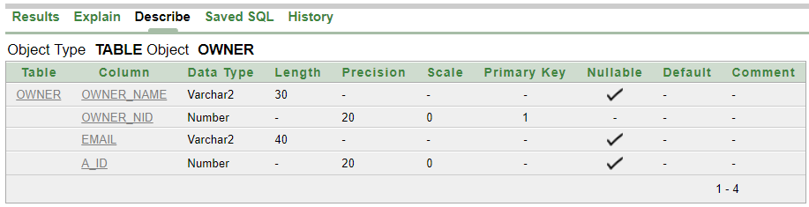

2. create table Location (a_id number(20) primary key,city varchar2(10), country varchar2(20));

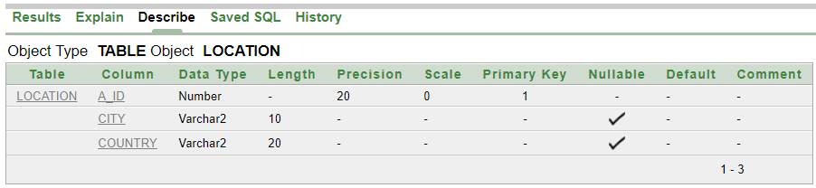

3. create table Coffee_Shop (licence number(35) primary key, cs_name varchar2(20),cs_address varchar2(30), owner_NID number(10));

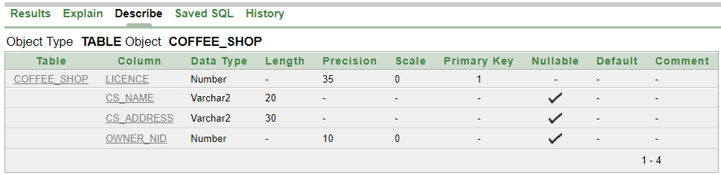

4. create table Brance (b_name varchar2(20),b_id number(20) primary key,b_address varchar2(20),licence number(35));

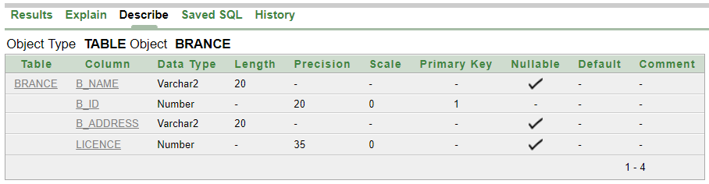

5. create table Employee(gender varchar2(10), role varchar2(20), e_id number(20), e_phone_no number(20),salary number(10),a_id number(20),b_id number(20));

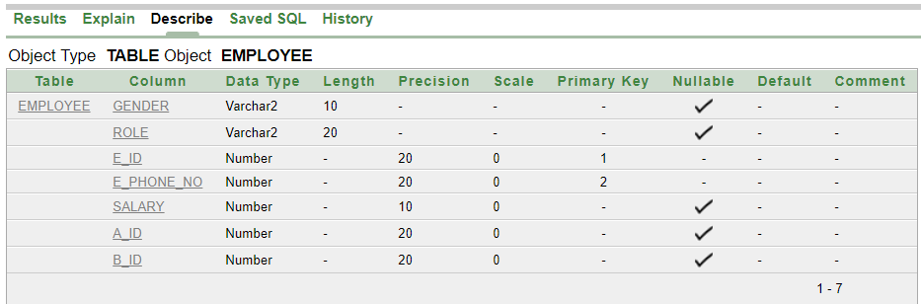

6. create table fk_b1 (b_name varchar2(20),b_id number(20) primary key,b_address varchar2(20),m_id number(10),m_phone_no number(20));

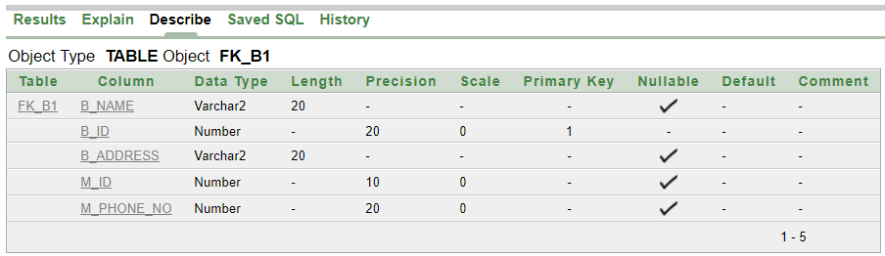

7. create table Manager(hiredate DATE,salary number(10),m_id number(10), m_phone_no number(20));

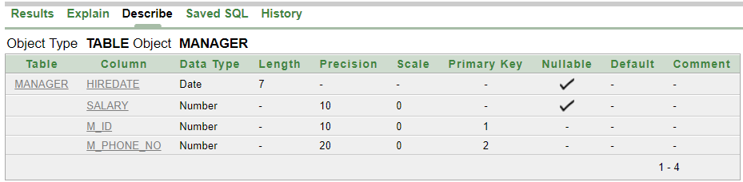

8. create table Chef (c_phone_no number(20),c_id number(10), C_name varchar2(20),salary number(10),m_id number(10), m_phone_no number(20));

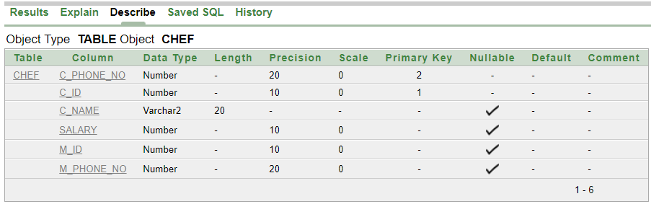

9. create table fk_c1(c_phone_no number(20),c_id number(10),i_id number(20));

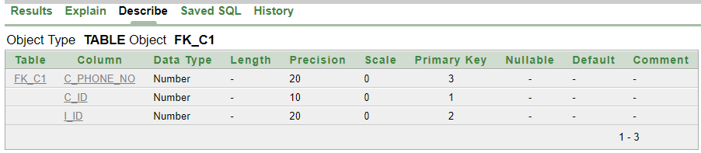

10. create table Item(i_id number(20) primary key,i_name varchar2(20),unit_price number(10),licence number(35));

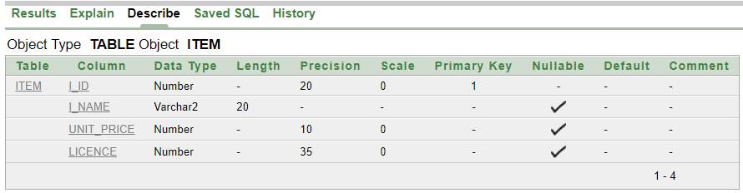

11. create table Customer(cust_id number(20) primary key, cust_name varchar2(15),licence number(35));

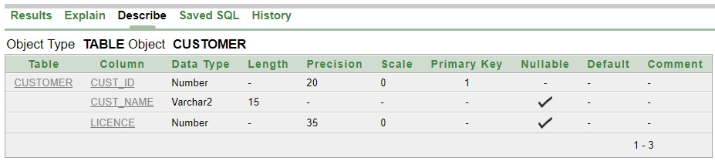

12. create table fk_cust1(cust_id number(20) primary key, cust_name varchar2(15),o_id number(10));

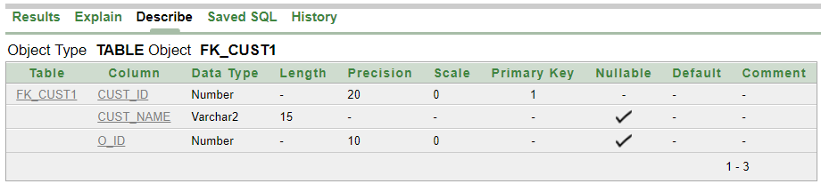

13. create table Order1(o_id number(10) primary key,o_date DATE, o_time number(10));

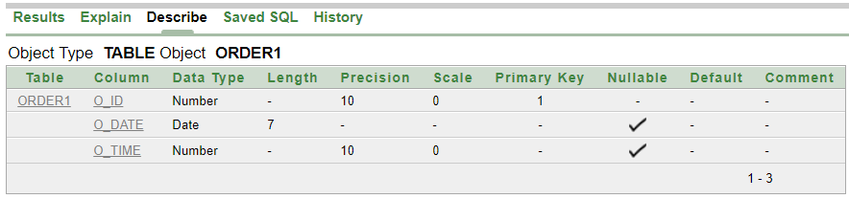

14. create table Bill (i_id number(20),c_id number(10),bill_id number(10),o_id number(10));

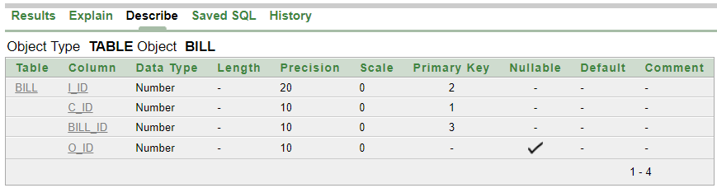

alter table Employee add constraint ae primary key (e_id, e_phone_no);

alter table Manager add constraint az primary key (m_id, m_phone_no);

alter table Chef add constraint ai primary key (c_id, c_phone_no);

alter table fk_c1 add constraint ak primary key (c_id,i_id,c_phone_no);

alter table Bill add constraint ar primary key (c_id,i_id,bill_id);

alter table Owner add constraint ab foreign key (a_id) references Location (a_id);

alter table Coffee_Shop add constraint ac foreign key (owner_NID) references Owner (owner_NID);

alter table Brance add constraint ad foreign key (licence) references Coffee_Shop (licence);

alter table Employee add constraint af foreign key (a_id) references Location (a_id);

alter table Employee add constraint ag foreign key (b_id) references Brance (b_id);

alter table fk_b1 add constraint ah foreign key (m_id,m_phone_no) references Manager (m_id,m_phone_no);

alter table Chef add constraint aj foreign key (m_id,m_phone_no) references Manager (m_id,m_phone_no);

alter table fk_c1 add constraint al foreign key (c_id,c_phone_no) references Chef (c_id,c_phone_no);

alter table fk_c1 add constraint am foreign key (i_id) references Item (i_id);

alter table Item add constraint ao foreign key (licence) references Coffee_Shop (licence);

alter table Customer add constraint ap foreign key (licence) references Coffee_Shop (licence);

alter table fk_cust1 add constraint aq foreign key (o_id) references Order1 (o_id);

alter table Bill add constraint au foreign key (o_id) references Order1 (o_id);

**DATA INSERTATION:**

**1. Owner:**

insert into owner values ('MD. RAHMAN',6245765237,'rahman@gmail.com',101);

**2. Location:**

insert into location values(101,'Rangpur','Bangladesh');

insert into location values(102,'Dhaka','Bangladesh');

insert into location values(104,'Tangail','Bangladesh');

insert into location values(107,'Khulna','Bangladesh');

**3. Coffee_Shop:**

insert into Coffee_Shop values(3489574923,'Apon Coffee Shop','Khilgaon',6245765237);

**4. Branch:**

insert into Brance values('Apon Coffee Shop',1221,'Khilgaon',3489574923);

insert into Brance values('Apon Coffee Shop',1222,'Gulshan',3489574923);

insert into Brance values('Apon Coffee Shop',1223,'Bashundhara r/a',3489574923);

insert into Brance values('Apon Coffee Shop',1224,'Uttara',3489574923);

insert into Brance values('Apon Coffee Shop',1225,'Kuratoli',3489574923);

**5. Employee:**

insert into Employee values('Male','Accountent',073,0173331273,8000,101,1221);

insert into Employee values('Female','Accountent',074,0197331273,8000,102,1224);

insert into Employee values('Male','Waiter',075,0178331273,5000,107,1221);

insert into Employee values('Male','Accountent',076,0189331273,8000,104,1223);

insert into Employee values('Male','Waiter',077,0172331273,5000,104,1224);

insert into Employee values('Female','Waiter',078,0179331273,5000,107,1222);

insert into Employee values('Female','Accountent',079,0173331073,8000,102,1225);

insert into Employee values('Male','Waiter',080,0173331272,5000,101,1223);

insert into Employee values('Female','Accountent',082,0163331273,8000,104,1222);

insert into Employee values('Male','Waiter',085,0153331273,5000,101,1225);

**6. fk_b1:**

insert into fk_b1 values('Apon Coffee Shop',1221,'Khilgaon',922,0182376599);

insert into fk_b1 values('Apon Coffee Shop',1222,'Gulshan',923,0182376590);

insert into fk_b1 values('Apon Coffee Shop',1223,'Bashundhara r/a',924,0162376587);

insert into fk_b1 values('Apon Coffee Shop',1224,'Uttara',926,0197676599);

insert into fk_b1 values('Apon Coffee Shop',1225,'Kuratoli',929,0182907599);

**7. Manager:**

insert into Manager values(to_date('01-07-2017','dd-mm-yyyy'),15000,922,0182376599);

insert into Manager values(to_date('01-12-2017','dd-mm-yyyy'),15000,923,0182376590);

insert into Manager values(to_date('02-06-2017','dd-mm-yyyy'),15000,924,0162376587);

insert into Manager values(to_date('01-03-2017','dd-mm-yyyy'),15000,926,0197676599);

insert into Manager values(to_date('03-11-2017','dd-mm-yyyy'),15000,929,0182907599);

**8. Chef:**

insert into Chef values(01321763654,201,'Tanjib',7000,922,0182376599);

insert into Chef values(01321763659,202,'Tushar',7000,923,0182376590);

insert into Chef values(01421763654,203,'Shahriar',7000,924,0162376587);

insert into Chef values(01921763654,207,'Shamsu',7000,926,0197676599);

insert into Chef values(01321763666,208,'Alam',7000,929,0182907599);

**9. fk_c1:**

insert into fk_c1 values(01321763654,201,3002);

insert into fk_c1 values(01321763659,202,3001);

insert into fk_c1 values(01321763654,201,3003);

insert into fk_c1 values(01321763659,202,3004);

insert into fk_c1 values(01421763654,203,3007);

insert into fk_c1 values(01921763654,207,3005);

insert into fk_c1 values(01321763666,208,3006);

insert into fk_c1 values(01421763654,203,3010);

insert into fk_c1 values(01321763666,208,3008);

insert into fk_c1 values(01921763654,207,3009);

**10. Item:**

insert into Item values(3001,'Cold Coffee',180,3489574923);

insert into Item values(3002,'Milk Shake',140,3489574923);

insert into Item values(3003,'Hot Coffee',120,3489574923);

insert into Item values(3004,'Oreo Shake',180,3489574923);

insert into Item values(3005,'Mars Shake',170,3489574923);

insert into Item values(3006,'Virgin Mojito',170,3489574923);

insert into Item values(3007,'Blue Lime',180,3489574923);

insert into Item values(3008,'Naga Burger',275,3489574923);

insert into Item values(3009,'Naga Wings',175,3489574923);

insert into Item values(3010,'Pizza',765,3489574923);

**11. Customer:**

insert into Customer values(2209,'Emon',3489574923);

insert into Customer values(2212,'Jeelan',3489574923);

insert into Customer values(2213,'Amit',3489574923);

insert into Customer values(2240,'Tushar',3489574923);

insert into Customer values(2258,'Samiul',3489574923);

insert into Customer values(2269,'Surobe',3489574923);

**12. fk_cust1:**

insert into fk_cust1 values(2209,'Emon',01);

insert into fk_cust1 values(2212,'Jeelan',02);

insert into fk_cust1 values(2258,'Samiul',05);

insert into fk_cust1 values(2269,'Surobe',06);

**13. Order1:**

insert into Order1 values(01,to_date('01-07-2019','dd-mm-yyyy'),0427);

insert into Order1 values(02,to_date('11-07-2019','dd-mm-yyyy'),0652);

insert into Order1 values(05,to_date('21-07-2019','dd-mm-yyyy'),0654);

insert into Order1 values(06,to_date('24-07-2019','dd-mm-yyyy'),0702);

insert into Order1 values(07,to_date('07-08-2019','dd-mm-yyyy'),0710);

insert into Order1 values(09,to_date('24-08-2019','dd-mm-yyyy'),0800);

**14. Bill:**

insert into Bill values(3001,2209,01,01);

insert into Bill values(3002,2212,02,02);

insert into Bill values(3003,2213,05,05);

insert into Bill values(3004,2240,06,06);

insert into Bill values(3008,2258,07,07);

insert into Bill values(3009,2269,09,09);

**QUERY WRITING:**

**Single Row Functions:**

Ques: Show the name of all customer.

Ans: select UPPER(cust_name) from Customer;

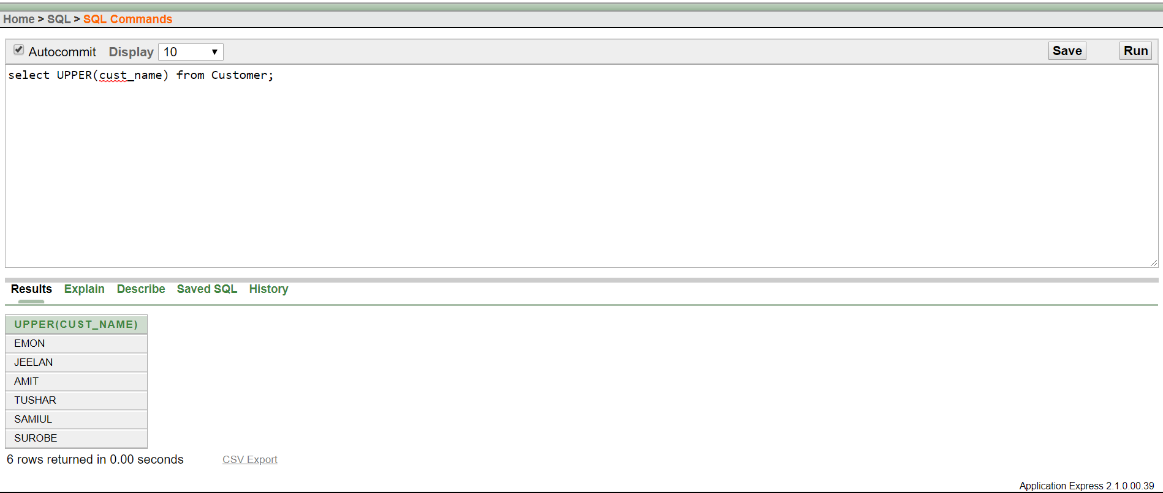

Ques: Display the place name in upper case.

Ans: select UPPER(city) from Location;

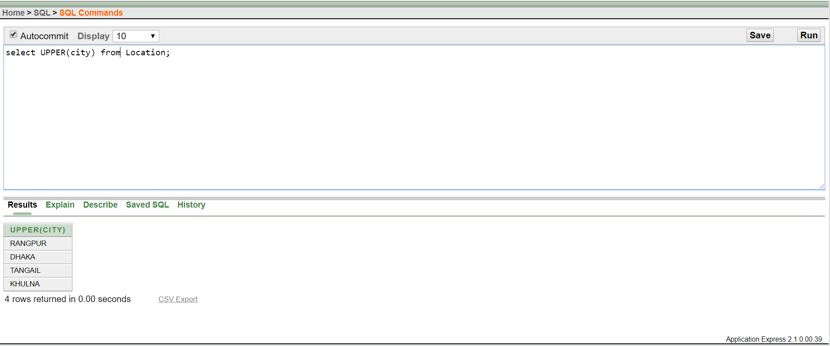

**Group Function:**

Ques: Find the average salary of the employees.

Ans: select AVG (salary) AS AVERAGE_EMPLOYEE_SALARY from Employee;

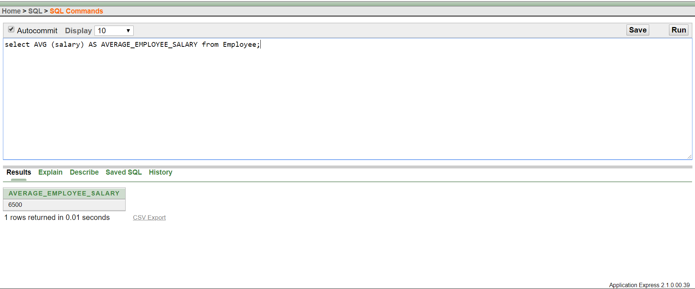

Ques: Find maximum salary of a manager.

Ans: select MAX(salary) as MAX_SALARY from Manager;

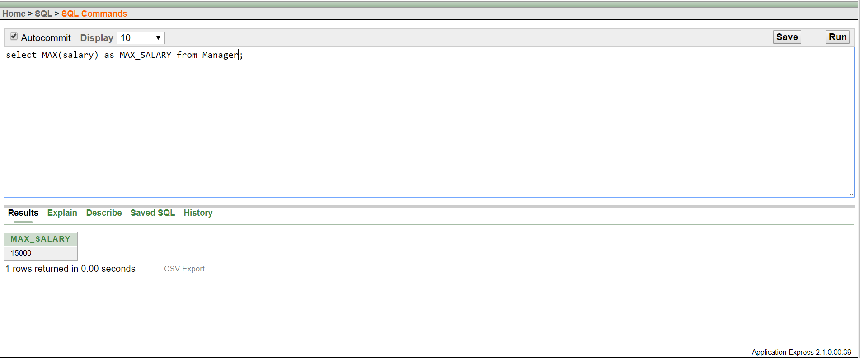

**Sub Query:**

Ques: Find the role of employees who get more salary then e_id= 075.

Ans: select role from Employee where salary > (select salary from Employee where e_ID=075);

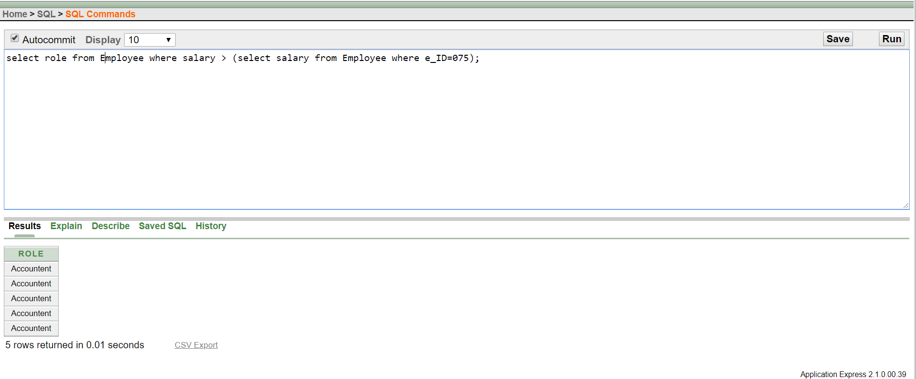

Ques: Find the name of items which prices is more then i_id=3005.

Ans: select i_name from Item where unit_price > (select unit_price from Item where i_ID=3005);

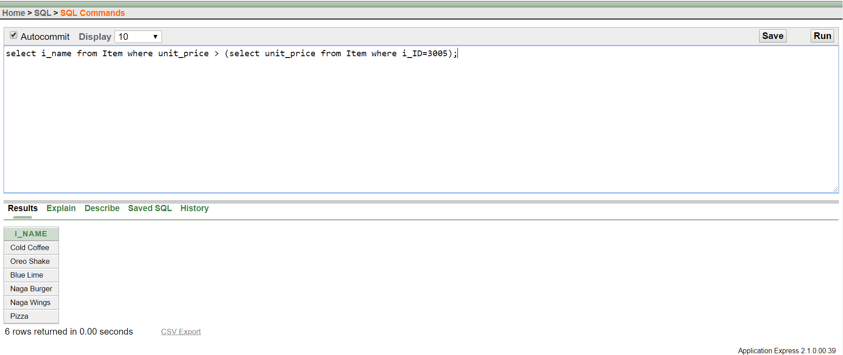

**Joining:**

Ques: Show the length of chef name and join their id and name.

Ans: select c_name,LENGTH(c_name) as "Length" ,CONCAT(c_id,c_name) as "Id and name" from chef;

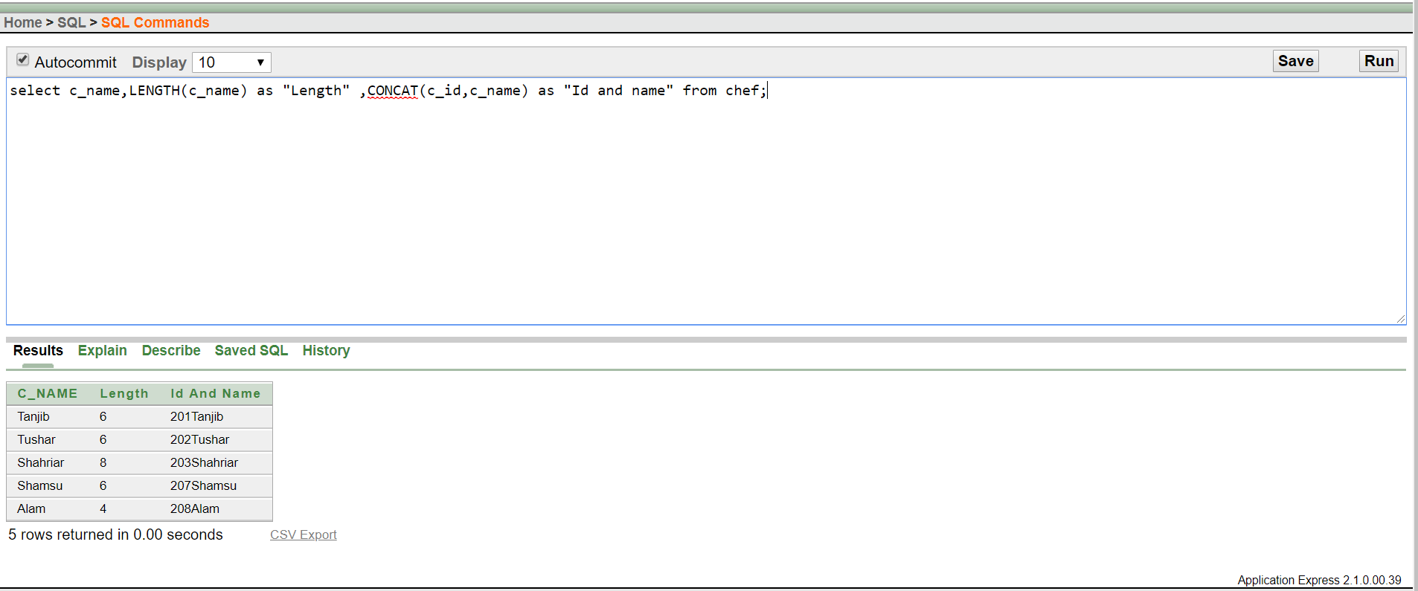

Ques: Display the manager ID and his chef name.

Ans: select Manager.m_id, Chef.c_name from Manager, chef where Manager.m_ID= Chef.m_ID;

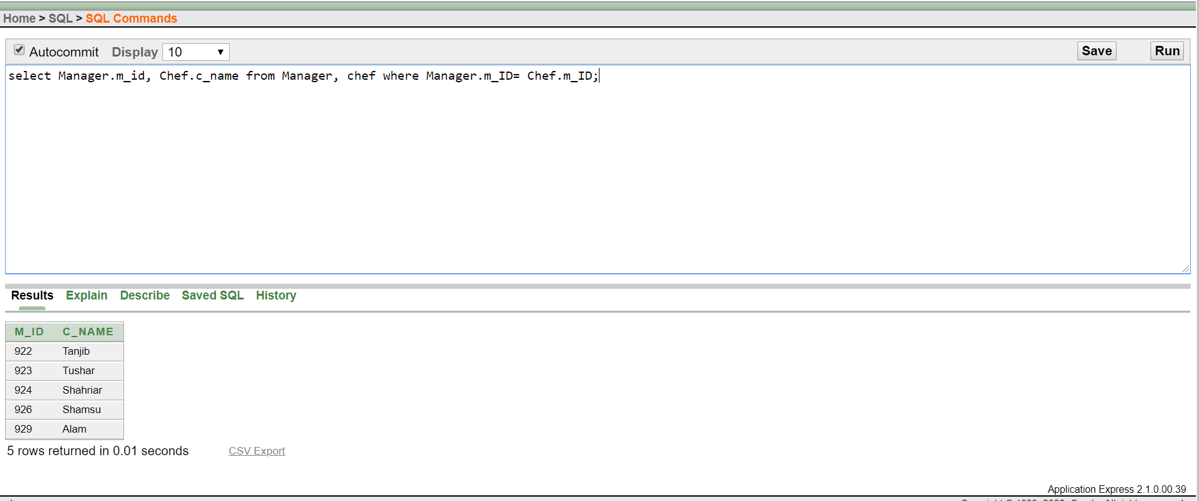

**Conclusion :**

After lots of hard works of all our group member. We are able to create our database project “Coffee Shop Management System”. While doing the project we faced some difficulty and we overcome that. Now we are confident about our project. Hopefully in future we will be able to create a real database system for any purpose.